**IFT 266 Introduction to Network Information Communication Technology (ICT)**

**Lab 41**

**IPv6 and IPv4 Dual Stack**

Co-authored by Joshua Nash

**After you complete each step, put a ‘√’ or ‘x’ in the completed box   
  
or**

**Answer the open questions in the spaces provided.**

**Objective:** Demonstrate the process to set up Dual Stacking to allow for upgradable devices so IPv6 and IPv4 can work along together.

1. Set up the following topology as shown.

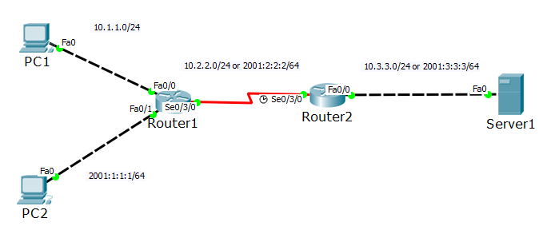



**Note:** 1841 router might be a good option.

1. Configure PC 1 which will be IPV4 focused.

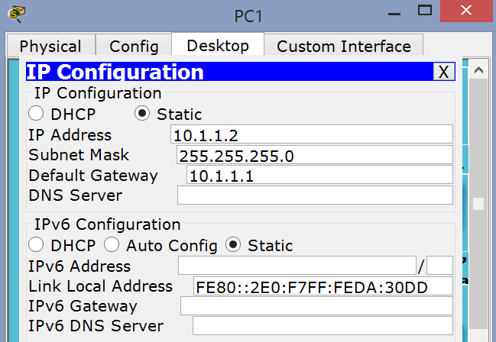



1. Configure PC 2 which will be IPV6 focused.

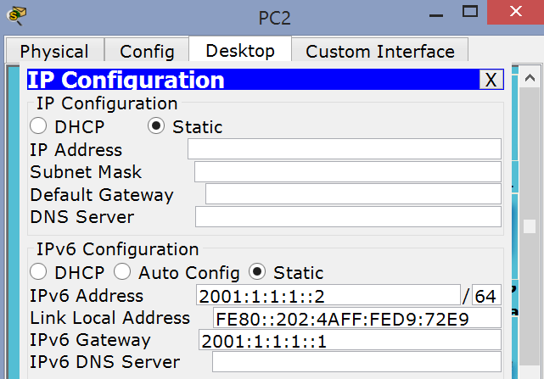



1. Configure the Server as shown with IPv4 and IPv6 configurations.

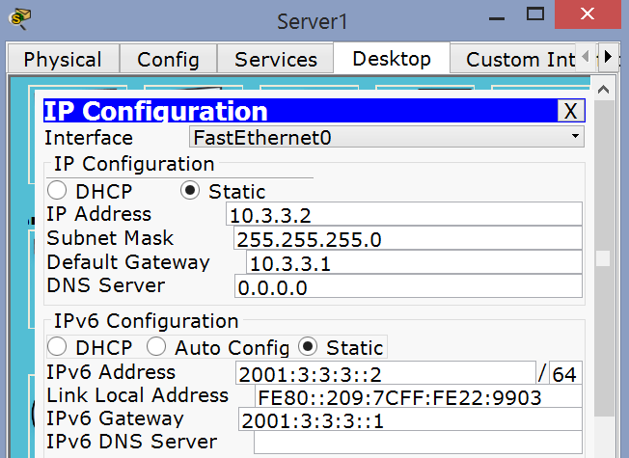



1. Router configuration details. You will use these configuration details in step 6.

|  |  |
| --- | --- |
| **Device** | **IP Address** |
| R1-Fa0/0 | 10.1.1.1/24 |
| R1-Fa0/1 | 2001:1:1:1::1/64 |
| R1-S0/3/0 | 10.2.2.1/24 |
| R1-S0/3/0 | 2001:2:2:2::1/64 |
| R2-S0/3/0 | 10.2.2.2/24 |
| R2-S0/3/0 | 2001:2:2:2::2/64 |
| R2-Fa0/0 | 10.3.3.1/24 |
| R2-Fa0/0 | 2001:3:3:3::1/64 |

1. Configure R1 with the following commands

Router>en

Router#config t

Enter configuration commands, one per line. End with CNTL/Z.

Router(config)#

Router(config)#interface FastEthernet0/0

Router(config-if)# ip address 10.1.1.1 255.255.255.0

Router(config-if)#no shutdown

%LINK-5-CHANGED: Interface FastEthernet0/0, changed state to up

%LINEPROTO-5-UPDOWN: Line protocol on Interface FastEthernet0/0, changed state to up

Router(config)#interface FastEthernet0/1

Router(config-if)#ipv6 address 2001:1:1:1::1/64

Router(config-if)#no shutdown

Router(config-if)#exit

Router(config)#interface Serial0/3/0

Router(config-if)#ip address 10.2.2.1 255.255.255.0

Router(config-if)#ipv6 address 2001:2:2:2::1/64

Router(config-if)#no shutdown  
Router(config-if)#exit



1. Configure Router 2 using the same process that you did when configuring Router 1 in step 6

1. Let’s do some testing of the network

Try to ping Router 1 with the IPv4 address from PC-0.   
  
Can you do it? Yes  
  
YES…you should be able to ping Router 1 from PC 1 via the IPv4 address

If not, troubleshoot.



Try to ping Router 1 with IPv6 address from PC-1.   
  
Can you do it? Yes  
  
YES…you should be able to ping Router 1 from PC 2 via the IPv6 address

If not, troubleshoot.

Can you ping Router 2 from either PC 1 or PC 2?

YES or NO

If no, why can’t you?

No because PC0 is ipv4 configured and PC1 is ipv6 configured

1. We will configure our routers so they will learn about the network to which they are not directly connected.   
     
   Rather than using routing protocols, we will manually configure some static routes. There are several ways to configure static routes on a router.

We will now configure Router 1 with static routes for both the IPv4 and IPv6 networks

Router(config)#ip route 0.0.0.0 0.0.0.0 10.2.2.2

Router(config)#ipv6 route ::/0 2001:2:2:2::2



We will now configure Router 2 as we did with Router 1

Router(config)#ip route 0.0.0.0 0.0.0.0 10.2.2.1

Router(config)#ipv6 route ::/0 2001:2:2:2::1



1. Now try to ping Router 2 from both PC’s.   
     
   Did it work?   
     
   Yes and No.

PC 1 should have been able to ping Router 2 but PC 2 could not.



1. We must turn on IPv6 routing on both routers. Repeat this same command on both routers.   
     
   Router(config)#ipv6 unicast-routing



1. Now try to ping the server from PC 2 via the IPv6 address.  
     
   Did it work? Yes  
     
   It should work now…..if not, troubleshoot.



1. Finally, ping both PCs from the server (PC1 via the IPv4 address and PC2 via the IPv6 address).

Did it work?Yes  
  
It should work not, if not, troubleshoot.

